**The Impact Of Social Media On Communication**

Analysis Of Digital Interaction In the 21st Century

Name : Muhammad Siddique

Roll NO : 25K-0610

Section : BCS-1C

Subject : ICT Assignment 1

Contents

Introduction : 3

The Evolution Of Communication : 3

The Role Of Social Media Platforms : 4

Positive Effects of Social Media on Communication : 5

Negative Effects of Social Media on Communication : 6

Case Studies of Social Media Influence 7

Conclusion 8

# Introduction :

First Of All, seriously look back over the last two decades. Social media has dramatically altered how we communicate, from the early days of MySpace to the dominance of Facebook and TikTok (Carr, 2010). It is insane how social media has re-wired our brains for connection. Who could have guessed back in the Myspace(2005-2009) days that platforms like Facebook and TikTok would become this absolute unit running everything? It's not just for texting your friends anymore; it is the main hustle for networking, shopping, and straight-up smackdowns in political arguments. Keeping up with your global crew is easier than ever, true, but let's be real, it has also dropped a dump truck of drama right into our laps. This whole report is a deep check into that chaotic mess, weighing the wins against the absolute Ls, and trying to see just how deeply rooted this digital life has become.

# The Evolution Of Communication :

Secondly, The evolution of communication from face-to-face interactions to the digital age can be traced back to the rise of email and early internet technologies (Bohn, 2008). Before we get lost in our infinite scrolls, we actually had to talk to people the old-fashioned way: face-to-face, over the phone, or by writing letters. It worked, but let's be honest, it was a total mission, especially if you lived miles away or had to time things perfectly just to catch a call. Then the internet hit us in the late '90s, and boom—everything sped up. Email, IM, and video calls started smashing the distance barrier, letting us chat instantly, no matter the map coordinates.

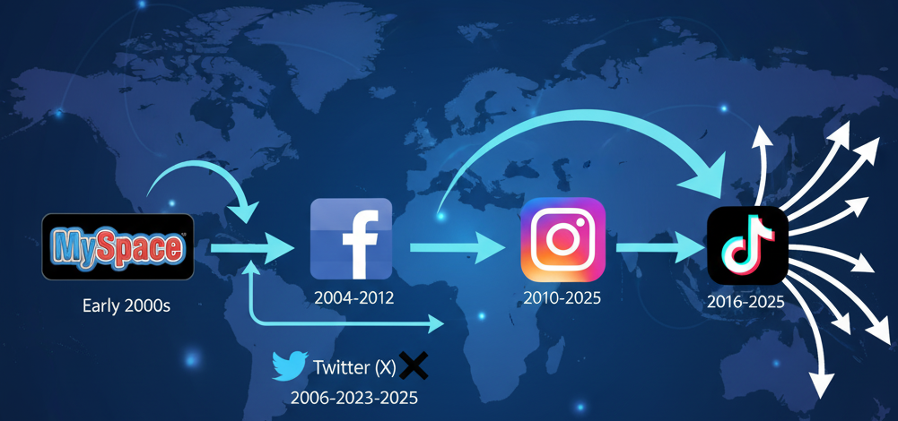

But here is the real pivot point: Email was just the warm ups the act. The genuine revolution? That was the social media comeover in the early 2000s. MySpace was a fun mess of custom pages, but it was Facebook that truly flipped the switch, showing us the power of being connected 24/7. Twitter and Instagram then cranked the volume. These platforms werenot just friend finders, they became our main feed for breaking news, landing gigs, and even kicking off genuine movements online.

# The Role Of Social Media Platforms :

Thirdly, When social media hit, it didnot just change how we talk, it blew up the whole way of communication. Now, every platform is its own unique beast, designed for different things we want to do.

Platforms like Facebook, Instagram, and TikTok have become essential tools for global communication, offering real-time news updates and shaping business practices (Wellman, 2012). Take Facebook, for example. It is like the Swiss Army knife; you use it to keep up with Grandma and to network with colleagues, all while joining groups for your hobbies. Then there's Twitter (or X), which is all about being short, fast, and now. It’s the perfect spot for breaking news, heated debates, and quick public statements.

Instagram totally flipped the script, making everything visual. We basically talk in photos and quick clips now, and that focus on looking good has changed everything from how we brand ourselves to how companies advertise. And of course, TikTok showed up and proved that short, creative videos are king, leading to massive viral trends.

Basically, these platforms have become the backbone of how we live and work, giving us crazy reach and instant connection. But, as we all know, they arenot perfect. They still leave us scratching our heads over issues like privacy, fake news, and who gets left out of the digital party.

|  |  |  |
| --- | --- | --- |
| Aspect | Positive Aspects | Negative Aspects |
| Global Connectivity | |  | | --- | |  |  |  | | --- | | Helps users stay connected globally (family, friends, etc.) | | Over-reliance on digital interactions, leading to isolation |
| Instant Communication | Facilitates real-time messaging (e.g., Twitter, WhatsApp) | Communication is often superficial, lacks depth |
| Access to Information | |  | | --- | |  |  |  | | --- | | Provides instant access to news, trends, and updates | | Misinformation and fake news spread rapidly |
| Career and Networking | LinkedIn helps professionals network, find jobs, and promote expertise | LinkedIn can sometimes lead to a focus on professional image over genuine connections |
| Community Building | Allows niche communities to form (e.g., hobby groups, causes) | Allows niche communities to form (e.g., hobby groups, causes) |
| Mental Health Impact | Can provide support for marginalized groups and mental health awareness | Can provide support for marginalized groups and mental health awareness |

Social media’s dual effects, both positive and negative are well documented, with benefits like career networking and community building, but also challenges like mental health issues (Turkle, 2015).

# Positive Effects of Social Media on Communication :

In Addition, let's dive into the definite wins! The biggest, most awesome thing social media ever did was flat-out shrink the planet. Seriously, in today's super global world, it’s ridiculously easy to keep up with your best friend who moved overseas or those cousins way across the country. Stuff like Messenger and X (formerly Twitter) means you get updates right now, making communication faster and way smoother than we could have ever imagined.

On top of that, social media has basically handed everyone a stadium microphone. Now, anyone can blast their opinions, wild experiences, and expertise out to a huge global crowd. Places like LinkedIn totally changed the game for our careers—you can network with industry big shots, hunt for jobs, and snag clients without being stuck inside your city's boundaries.

And it’s a huge community builder. People find their 'tribes' whether it’s for niche hobbies, shared backgrounds, or powerful causes. Activists have masterfully used platforms like X and Facebook to kick off major social movements, organizing massive protests and shining a global spotlight on critical issues, from climate change and racial justice to gender rights.

# Negative Effects of Social Media on Communication :

Let's dive into the definite wins! The biggest, most awesome thing social media ever did was flat out shrink the planet. Seriously, in today's super global world, it is ridiculously easy to keep up with your best friend who moved overseas or those cousins way across the country. Stuff like Messenger and X (formerly Twitter) means you get updates right now, making communication faster and way smoother than we could have ever imagined.

On top of that, social media has basically handed everyone a stadium microphone. Now, anyone can blast their opinions, wild experiences, and expertise out to a huge global crowd. Places like LinkedIn totally changed the game for our careers, you can network with industry big shots, hunt for jobs, and snag clients without being stuck inside your city's boundaries.

And it is a huge community builder. People find their 'tribes', whether it is for niche hobbies, shared backgrounds, or powerful causes. Activists have masterfully used platforms like X and Facebook to kick off major social movements, organizing massive protests and shining a global spotlight on critical issues, from climate change and racial justice to gender rights.

The growth of platforms like Facebook, Instagram, and TikTok has been remarkable, with Facebook reaching 2.9 billion active users by 2022 (Statista, 2022).

Case Studies of Social Media Influence :

You're looking to take a case-study driven text and make it sound like a compelling article or documentary segment. I'll translate the formal language into dynamic, real-world examples and analysis.

The Real-World Impact: Case Studies That Prove the Point "Want to see how much social media actually matters? Just look at a few real-world moments where it completely took the driver's seat.

The Arab Spring highlighted social media’s transformative role in organizing protests and disseminating information, bypassing traditional media channels (Harris, 2011). This was a masterclass in modern activism. People didn't rely on state TV; they grabbed their phones. They used Twitter, Facebook, and YouTube to organize massive protests, share real-time info, and broadcast live footage to the entire international community, totally bypassing the official gatekeepers.

In the business world, it's the same story. Companies like Starbucks aren't just selling coffee; they're living on Twitter and Instagram to instantly chat with customers, handle complaints, and hype up new products. Social media lets businesses ditch the corporate wall and connect with their audience in real time, building a much more personal relationship.

But the flip side is heavy, the mental health toll is a big cost, especially for young people. When we talk about platforms like Instagram, studies show that constant use causes problems with body image, self esteem, and comparison sickness. The rise of influencers and a fact that everyone only posts their perfect moments has created a culture where comparing your reality to a flawless feed is routine, and that leaves way too many people feeling inadequate or just plain dissatisfied with their own lives.

Conclusion :

So, here is the deal, social media has totally rewritten the communication rulebook. It is awesome for meeting people, snagging information, and jumping into global chats, no doubt about it. But let's be real, its rise brought some seriously ugly baggage. We're talking less face-to-face time, a flood of fake news, those constant privacy headaches, and a definite toll on our mental health.

As these platforms keep changing, the core challenge is figuring out that balance. The future of talking to each other in this digital world won't be about running away from social media; it will be about using it smarter and more responsibly while actively fighting its bad effects.

In the end, how social media impacts us all comes down to us. It is about how we, as a society and as individuals, adapt to the chaos and choose how we show up on these platforms every single day.

# References

Bohn, R. S. (2008). *The Internet: A Historical Encyclopedia.* Westport , CT: Praeger.

Carr, N. (2010). *The Shallows: What the Internet Is Doing to Our Brains.* New York: W.W. Norton & Company.

Harris, P. (2011). *The Revolution Will Not Be Tweeted: Social Media and the Arab Spring.* London: University of London Press.

Statista. (2022). *Statista*. From Social Media Statistics 2022: https://www.statista.com/statistics/264810/number-of-monthly-active-facebook-users-worldwide/

Turkle, S. (2015). *Reclaiming Conversation: The Power of Talk in a Digital Age.* New York: Penguin Press.

Wellman, L. R. (2012). *Networked: The New Social Operating System.* Cambridge, MA: MIT Press.

Zuboff, S. (2019). *The Age of Surveillance Capitalism: The Fight for a Human Future at the New Frontier of Power.* New York: PublicAffairs.